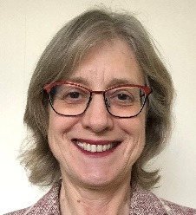 | Vicki Fruish  Little Gaddesden  Hertfordshire | Tel: 07768 454104
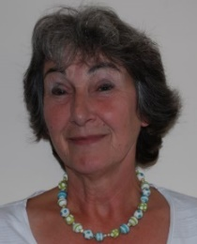 | Lyn Hyde  22/23 Little Gaddesden  Hertfordshire  HP4 1NU | Tel: 01442 842267
 | Paul Kelly (Chair)  Coach House  The Green  Little Gaddesden  HP4 1PH | Tel: 07879 443333
 | Kathryn Magson (Vice Chair)  Badgers Wood,  Beacon Road,  Ringshall  HP4 1NE | Tel: 01442 842797
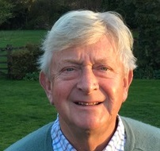 | John Saner  Bury Orchard  Hudnall Common  HP4 1QL | Tel: 01442 843428
 | Lesley Thompson  West Beaney  Little Gaddesden  HP4 1PE | Tel: 01442 843366
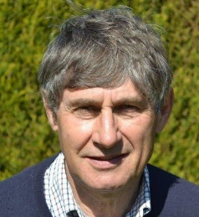 | Jim Townsend  20 Little Gaddesden  HP4 1PA | Tel: 01442 842421
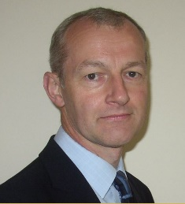 | Alastair Greene CLERK  Bramleys  1 Pond Lane  Little Gaddesden  HP4 1UB | Tel: 01442 842795  Our web site address is:-  www.littlegaddesdenpc.org.uk

